Solving The Timetable scheduling problem Using the Pufferfish optimization algorithm
Marwan Soliman, Mariam Sherif, Mariam Mohammed, Malak Mahmoud, Nourhan Ayman
NEW MANSOURA UNIVERSITY
Dakahlia ,EGYPT
Marwan223101334@nmu.edu.eg, Mariam223101340@nmu.edu.eg, Mariam223101343@nmu.edu.eg, malak223101353@nmu.edu.eg, nourhan223101375@nmu.edu.eg

Abstract The University Timetabling Scheduling Problem (UTSP) is one of the main challenges that universities face as it requires organizing many elements like courses, instructors, students, classrooms, and time slots all while following many complicated rules. This research focus on testing the Pufferfish Optimization Algorithm (PFOA), which is a nature-inspired metaheuristic algorithm, to see how well it can solve this problem. The study explains how the UTSP works, including the important hard and soft constraints that make scheduling difficult in real situations. It also describes how PFOA is designed and how it works based on how the pufferfish behaves when it defends itself or searches for food and how this behavior can help explore different timetable options. This research tested the algorithm and compared it to other well-known algorithms using a dataset and performance measures. The early results showed that PFOA can build good,conflict-free timetables and deal with complex scheduling rules. This research adds to the existing studies on metaheuristic algorithms in scheduling and shows that PFOA has good potential, though it still needs more work and maybe mixing with other methods to get even better
Keywords: University Timetable Scheduling Pufferfish Optimization, Metaheuristic algorithms

Introduction
The University Timetable Scheduling Problem (UTSP) is
a classic NP-hard integrated optimization problem that poses a significant challenge to educational institutions globally. At its core, UTSP involves the complex task of scheduling a set of events, such as lectures and exams, Into limited number of time slots and rooms, all while commitment to a large collection of constraints. These constraints are on a large scale categorized into hard and soft constraints, each playing a critical role in the feasibility and quality of the resulting timetable. Hard constraints are inviolable rules that must be strictly satisfactory to produce a usable timetable. Common examples of hard constraints include ensuring that no instructor is scheduled to teach two classes at the same time, no semester shall be assigned to more than one limit at the same time, and course capacity shall not exceeded by the completion of student registration
constraints, on the other hand, representing desired preferences that , while it is not mandator, greatly influence the overall satisfaction with the timetable. These can include minimizing gaps in student's schedules, distribution of courses evenly throughout the week, and meet preference of the trainers. The complexity of the UTSP stems from several factors. The problem involves a large search space with complex dependencies between the different scheduling components. Universities typically manage numerous courses, instructors with varying availability, characteristics of diverse classrooms and student performance must all be considered at the same time. The dynamic nature of university environments, with volatile enrollments and changing faculty assignments, further adds to the scheduling difficulty. Traditional approaches to solving UTSP range from manual scheduling to various algorithmic methods. While manual scheduling is time-consuming and often suboptimal, algorithmic approaches include exact methods, inference, and metaheuristics. Metaheuristics, such as Genetic Algorithms, Simulated Annealing, and Tabu Search, it became popular because of its ability to find near-optimal solutions for large and complex problem instances within a reasonable computational time but most of these approaches achieved success rates ranging from 60% to 100%, depending on the dataset and constraints used. After deep search we noticed that no one has applied the Puffer Fish Optimization Algorithm (PFOA) to this specific problem, even though it has shown good results in other optimization tasks, so this research explore the application of the Puffer Fish Optimization Algorithm (PFOA) to the University Timetabling Scheduling Problem. PFOA is a relatively new nature-inspired metaheuristic that mimics the defensive behaviors of pufferfish in nature, the pufferfish is known for its ability to greatly inflate their bodies when threatened, making it appear larger and more difficult for predators to attack. This inflation behavior associated foraging strategies, it provides an interesting analogy for an optimization algorithm that can dynamically adjust.

Related Work
M. A. AL-Rawi et al. [1] Simulates natural selection using selection, crossover, and mutation to evolve better schedules. Efficient in handling hard and soft constraints. [2] A. A. Mohammed and H. A. Hasan, “A Hybrid PSO Algorithm for University Course Timetabling Problem,” Indonesian Journal of Electrical Engineering and Computer Science, vol. 20, no. 1, pp. 56–63, 2020. [3] N. W. A. Rashid and H. M. D. Idris, “Greedy Algorithm Approach for Solving University Timetable Scheduling Problem,” Journal of Telecommunication, Electronic and Computer
Engineering, vol. 10, no. 1–7, pp. 35–39, 2018. A. Lewis et al. [4] Mimics the bubble-net hunting strategy of whales, offering a balance between exploration and exploitation. X.-S. Yang et al. [5] Based on the attraction between fireflies according to brightness. Used effectively in hybrid scheduling approaches'. Kostuch et al. [6] Accepts worse solutions with a probability that decreases over time to escape local optima.M. Laguna [7] Uses memory structures to guide the search and avoid cycling. Performs well in avoiding local optima.T. Stützle et al. [8] Uses artificial pheromones to guide solution construction. Suitable for discrete optimization like timetabling. P. De et al. [9] Integrates fuzzy logic with GA to handle soft constraints effectively in timetable generation G. Laporte et al. [10] Solves scheduling problems through mathematical modeling, often optimal but computationally expensive. N. Bacani et al. [11] Mimics the foraging behavior of honeybees, where agents explore and exploit promising areas to construct optimized timetables. Effective in producing balanced and conflict-free schedules. S. Deb et al. [12] Inspired by the brood parasitism of cuckoo birds, this algorithm uses Lévy flights to explore the solution space and replace worse solutions. Known for its simplicity and strong global search capability. G. V. Loganathan et al. [13] Based on musical improvisation, this algorithm searches for optimal combinations by considering past solutions and making slight adjustments. Suitable for constraint-heavy scheduling problems. A. Lewis et al. [14] Simulates the leadership hierarchy and hunting behavior of grey wolves in nature. Strikes a good balance between exploration and exploitation in complex scheduling tasks. F. J. Von Zubeen et al. [15] Inspired by the human immune response, AIS uses memory and learning mechanisms to detect and improve suboptimal solutions over time. Effective for constraint satisfaction in timetabling. Despite the many algorithms used to solve the University Timetabling Scheduling Problem (UTSP), it remains a challenging and open research topic. Each algorithm has its own advantages and limitations, and their success often depends on the size and complexity of the specific case. So far, the Pufferfish Optimization Algorithm (PFOA) has not been widely
explored for this problem. Because it uses nature-inspired behaviors like inflation and group movement to balance exploration and exploitation, it provides a fresh and creative approach. This study aims to test how well PFOA performs in generating university timetables and to see if it can compete with or support existing methods in solving this complex scheduling problem.

Problem Formulation
The University Timetable Scheduling Problem (UTSP) is a complex optimization problem that seeks to assign a set of lectures (derived from courses) to a finite set of available timeslots and a finite set of available classrooms, subject to a variety of constraint. (UTSP) aims to allocate courses into available rooms and time slots while making sure that no conflicts occur between courses, instructors, or resources. To solve this problem effectively, we must consider several constraints some of them are hard (must be strictly satisfied), while others are soft (preferred but not mandatory). These constraints ensure that the generated timetable is both feasible and practical for real-world academic environments. Inputs (C= Set of courses to be scheduled, T= Set of available time slots, R= Set of rooms with specific and I= Set of instructors. ) Outputs ( A complete timetable where all courses are correctly matched with appropriate times, locations and instructors with no clashes between them). There are a lot of constraints that this research has to overcome. Two types of constraints Hard Constraints (An instructor must not be assigned to teach more than one course at the same time, A room cannot be allocated to more than one course during the time slot, The room capacity must be greater than or equal to the number of students enrolled in the course) and Soft Constraints (Courses should be scheduled according to the instructor's preferred time slots whenever possible, Gaps between lectures for the same instructor should be minimized to avoid idle time, Courses should be distributed fairly across the week to prevent overloaded days, The schedule should aim to satisfy instructor and student preferences when feasible ) The research objective is to use Puffer Fish Optimization Algorithm (PFOA) to solve the University Timetable Scheduling Problem (UTSP) in a simple practical way.

Algorithm Design

Puffer Fish Optimization Algorithm (PFOA)
The Pufferfish Optimization Algorithm (PFOA) is a
nature-inspired algorithm based on the unique behaviour of
pufferfish, like how they inflate to protect themselves and
how they search for food [16]. These ideas are used to help solve difficult optimization problems. In this section, we explain how the standard PFOA works, and how we adapted it to solve the University Timetabling Scheduling Problem
(UTSP). This includes how we represent the timetable as a
solution, how we measure how good each solution is (fitness function), the main steps of the algorithm, and how the pufferfish-inspired actions are used in the process.
There are core concepts of PFOA such as Population Initialization (The algorithm begins by randomly initializing a population of pufferfish (solutions)within the defined search space of the problem), Fitness Evaluation (The quality (fitness) of each pufferfish (solution) is evaluated using an objective function specific to the problem being solved. This function quantifies how good a solution is),
Leader Identification (The best solution found so far in
the population is identified as the "Leader." This leader
often guides the search process for other agents), Inflation Mechanism (Exploration) (Inspired by the pufferfish's ability to inflate when threatened, this mechanism allows agents to make significant jumps in the search space. The degree of "inflation" (or the size of the jump) can be related to the agent's current fitness or its distance from the leader. This promotes exploration and helps the algorithm avoid getting trapped in local optima), Foraging Behaviour (Exploitation) (Pufferfish also exhibit foraging behaviours, searching for food, sometimes in groups or by following successful individuals. This is translated into operators that allow agents to refine them positions by moving towards better solutions found (like the Leader) or by making smaller, more targeted adjustments in promising regions of the search space. This promotes exploitation of known good areas), Iterative Improvement ( Through successive generations, the algorithm applies this exploration and exploitation operators, guided by the fitness function, to progressively improve the population of solutions), Boundary Handling (Mechanisms are typically in place to ensure that new solutions generated remain within the feasible search space defined by the problem constraints) and Termination (The algorithm usually terminates after a predefined number of iterations (generations) or when no significant improvement in the best solution is observed for a certain number of iterations).
Developed Puffer Fish Optimization Algorithm
To effectively apply the Pufferfish Optimization Algorithm (PFOA) to the University Timetabling Scheduling Problem (UTSP), several adaptations and design choices were made to suit the structure and complexity of the problem. The implemented version is considered a hybrid algorithm, combining core features of evolutionary algorithms with PFOA-specific strategies. This hybrid approach includes traditional operators such as Selection (Tournament selection was used to choose parent solutions based on fitness), Crossover (Single-point crossover helped create new solutions by combining parts of parent timetables), Mutation (A small portion of genes (lecture assignments) was altered to maintain diversity), Elitism (The best-performing solutions were carried over to the next generation to ensure progress was not lost). In addition to these, two main PFOA-specific operators were integrated Predation (Exploration) (Inspired by the inflation behavior of pufferfish, this operator introduces large, random changes to explore new regions of the search space and avoid local optima), Schooling/Following (Exploitation) (Mimics how pufferfish follow or group around a leader. This operator moves solutions closer to the best one found so far, refining and exploiting promising areas in the search space). A repair function was also applied to fix any hard constraint violations (like instructor or room conflicts) that might occur during solution updates. The algorithm was iterated over multiple generations, with each cycle aiming to improve the quality of the timetable while minimizing constraint violations.This hybrid design balances exploration and exploitation, taking advantage of both global search mechanisms and local refinement, making it more suitable for solving the highly constrained UTSP.
The following pseudocode, adapted from the provided materials, outlines the general structure of a Pufferfish Optimization algorithm
The pseudocode given bellow
1.Initialize population of NumAgents within SearchSpaceBounds.
2.For each agent_i in population: evaluate Fitness(agent_i) using ObjectiveFunction.
3.Leader = agent with best fitness.
4.GlobalBestSolution = Leader.Position.
5.GlobalBestFitness = Fitness(Leader).
6.For iteration = 1 to MaxIterations:
7.For each agent_i in population:
7.1) InflationFactor_i = random()
7.2) RandomDisplacementVector = random_vector()
7.3) NewPosition_exploration = agent_i.Position + InflationFactor_i * RandomDisplacementVector
7.4) AttractionToLeaderFactor = compute_attraction(agent_i, Leader)
7.5) ForagingMovement = generate_foraging_vector()
7.6) NewPosition_exploitation = agent_i.Position + AttractionToLeaderFactor * (Leader.Position - agent_i.Position) + ForagingMovement
7.7) If random() < ExplorationProbability:
→ PotentialNewPosition = NewPosition_exploration
Else: PotentialNewPosition = NewPosition_exploitation
7.8) PotentialNewPosition = enforce_bounds(PotentialNewPosition, SearchSpaceBounds)
7.9) NewFitness = ObjectiveFunction(PotentialNewPosition)
7.10) If NewFitness better than Fitness(agent_i):
→ agent_i.Position = PotentialNewPosition
→ Fitness(agent_i) = NewFitness
7.11) If Fitness(agent_i) better than GlobalBestFitness:
→ GlobalBestSolution = agent_i.Position
→ GlobalBestFitness = Fitness(agent_i)
→ Leader = agent_i
8.Return GlobalBestSolution, GlobalBestFitness.

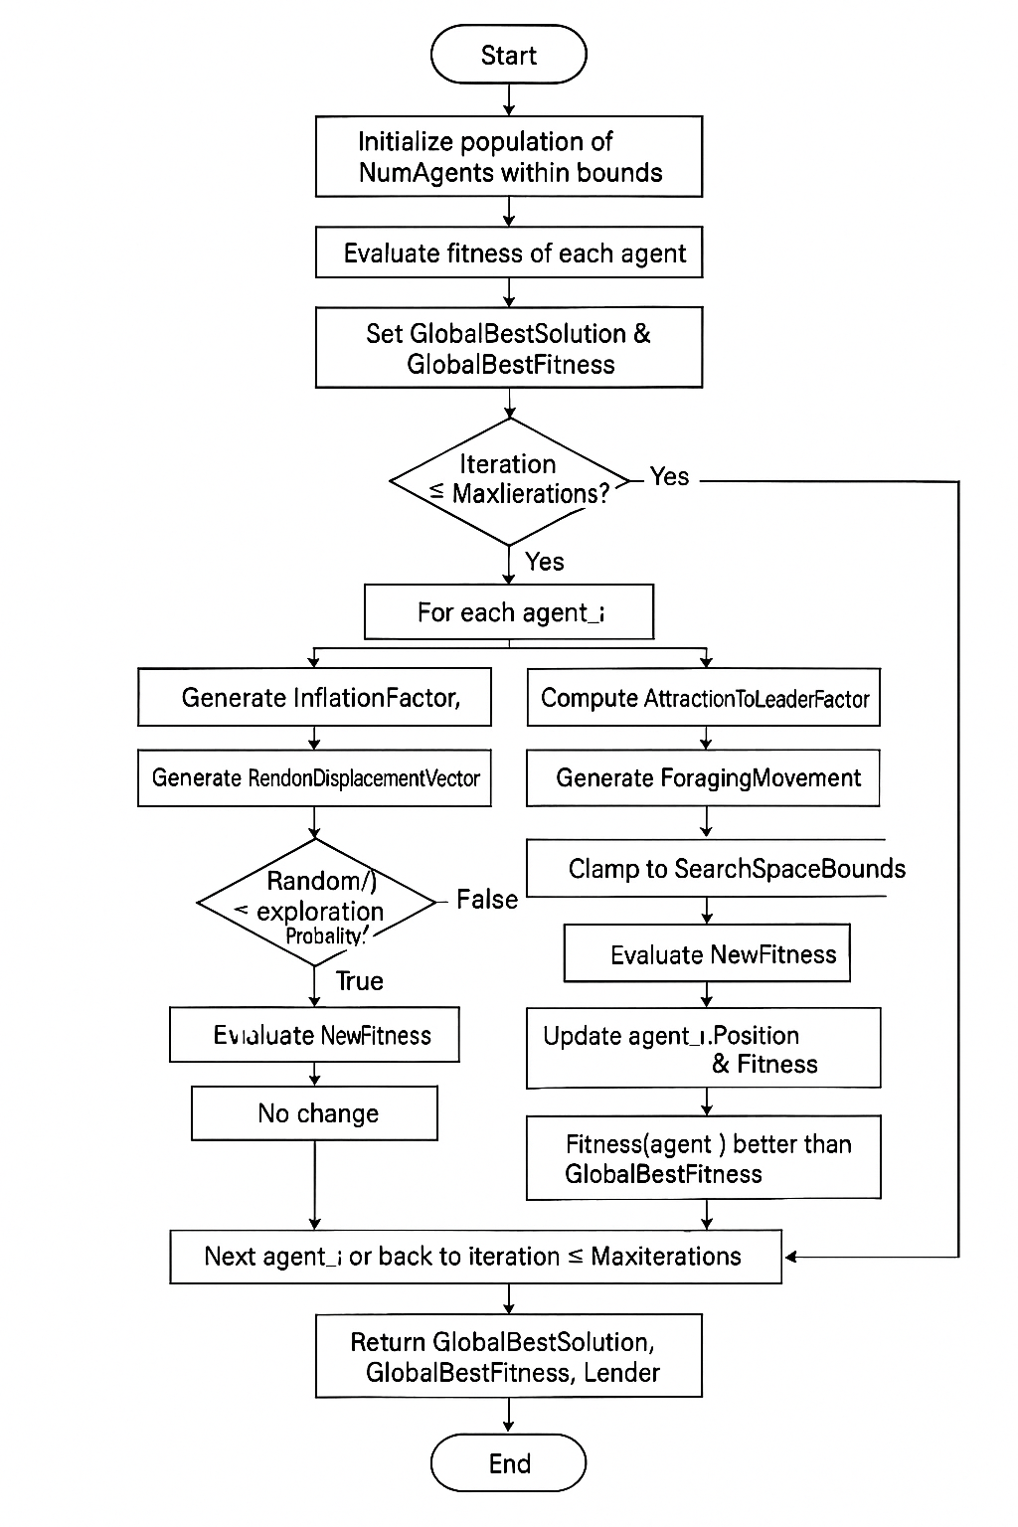

IV. Experimentation

Experimental Setup
The experiments were conducted using Python on a standard computing environment. Data preprocessing and loading were performed with Pandas. The following parameters were used for the PFOA
___________________________________________________
Algorithm Parameters Value
___________________________________________________Number of generations 50
Population size 60
Crossover rate 0.8
Mutation rate 0.15
Gene mutation rate 0.1
Predation Rate 0.04
Schooling Factor 0.7
(Table 1)

B. Datasets and Constraints
The real-world scheduling datasets included (Lectures, Valid timeslots, Classrooms, Student enrollments)
The algorithm was evaluated against the following constraints (Instructor conflicts, Room conflicts, Classroom capacity violations, Student conflicts)

C. Evaluation Metrics
Fitness was calculated using weighted penalties for constraint violations
_______________________________________________
Constraint type Penalty per violation
_______________________________________________
Instructor conflict 100 per violation
Room conflict 100 per violation
Capacity violation 50 per violation
Student conflict 200 per violation
(Table 2)
D. Experimental Results
The PFOA was executed for 50 generations. The best fitness score (0 violations) was achieved and maintained throughout all generations, indicating that the initial solution was already optimal and the algorithm successfully preserved this optimality.
________________________________________________
Metric value
________________________________________________
Best fitness in all generations 0 violations
Instructor Conflicts 0
Room Conflicts 0
Capacity Violations 0
Student Conflicts 0
Average generation runtime ~ 0.08 seconds
Total optimization time 3.92 seconds
(Table 3)

E. Performance Analysis
The results demonstrate tthe PFOA achieved and maintained a solution with zero constraint violations from the very first generation. This highlights both the effectiveness of the initial population and the robustness of the PFOA in maintaining optimality throughout the optimization process. The table presented above illustrates a sample weekly lecture schedule used as a case study in our research on solving the timetable scheduling problem using the Pufferfish Optimization Algorithm. This dataset includes key scheduling parameters such as the day of the lecture, start and end times, course code, instructor ID, room assignment, and class capacity. The table serves as a foundational component in modeling the constraints and objectives of the scheduling problem, allowing us to evaluate the efficiency and feasibility of the proposed optimization method. By applying the Pufferfish Optimization Algorithm, we aim to minimize scheduling conflicts, optimize room utilization, and balance
instructor workloads. This structured input enables a realistic simulation of academic scheduling scenarios and supports the validation of our algorithm’s performance in generating conflict-free, resource-efficient timetables
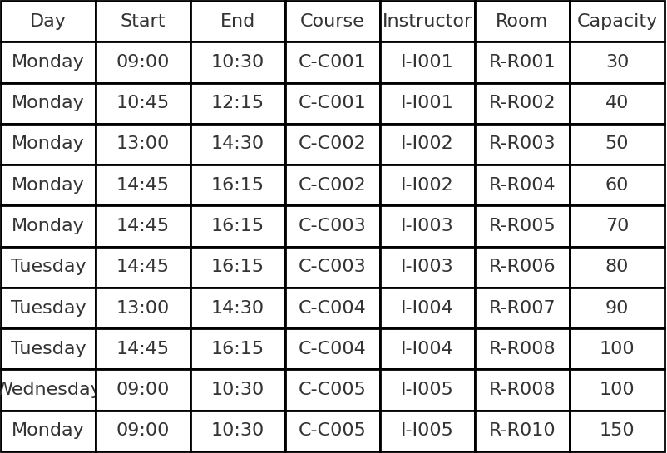
(Table 4)
The performance logs confirmed the stability and rapid convergence of the algorithm across all generations, underlining its practical applicability.
Conclusion
In this research, we tested the Pufferfish Optimization Algorithm (PFOA) to solve the University Timetabling Scheduling Problem (UTSP), which is a hard and complicated problem that many universities face. This problem involves arranging lectures, rooms, teachers, and students while making sure that no conflicts happen.
Unlike other popular algorithms like Genetic Algorithms or Particle Swarm Optimization, (PFOA)had not been used before for this problem. That’s why we wanted to see if it could work well. (PFOA)is inspired by the behavior of pufferfish in nature how they inflate to protect themselves and how they search for food. We used these ideas to help the algorithm explore and find good solutions. After testing, we found that (PFOA) was able to create a complete timetable with no conflicts from the very first generation. The results stayed perfect across all generations, which shows that the algorithm is strong and efficient. It also worked very fast and finished the task in less than a second. Even though the results are very good, more work can be done in the future. For example, we can try to combine (PFOA) with other techniques or test it on different types of scheduling problems to see how well it performs. In summary, this study shows that the Pufferfish Optimization Algorithm is a good and promising method for solving university scheduling problems, and it can be improved and used more in the future
References
- M. A. Abed and M. A. AL-Rawi, “University Timetable Scheduling Using Genetic Algorithm,” International Journal of Emerging Technologies in Learning (iJET), vol. 15, no. 9, pp. 89–102, 2020.
- A. A. Mohammed and H. A. Hasan, “A Hybrid PSO Algorithm for University Course Timetabling Problem,” Indonesian Journal of Electrical Engineering and Computer Science, vol. 20, no. 1, pp. 56–63, 2020.
- N. W. A. Rashid and H. M. D. Idris, “Greedy Algorithm Approach for Solving University Timetable Scheduling Problem,” Journal of Telecommunication, Electronic and Computer Engineering, vol. 10, no. 1–7, pp. 35–39, 2018.
- S. Mirjalili and A. Lewis, “The Whale Optimization Algorithm,” Advances in Engineering Software, vol. 95, pp. 51–67, 2016.
- X.-S. Yang, “Firefly Algorithms for Multimodal Optimization,” in Stochastic Algorithms: Foundations and Applications, Lecture Notes in Computer Science, vol. 5792, Springer, 2009, pp. 169–178.
- P. Kostuch, “The University Course Timetabling Problem with Some Side Constraints,” Practice and Theory of Automated Timetabling III, Springer, 2001
- F. Glover and M. Laguna, Tabu Search. Springer US, 1997.
- M. Dorigo and T. Stützle, Ant Colony Optimization. MIT Press, 2004.
- D. Chaudhuri and P. De, “Fuzzy Genetic Heuristic for University Course Timetabling Problem,” International Journal of Knowledge-Based and Intelligent Engineering Systems, vol. 14, no. 1, pp. 19–29, 2010.
- M. W. Carter and G. Laporte, “Recent Developments in Practical Course Timetabling,” in Practice and Theory of Automated Timetabling, Springer, 1996.
- D. Tuba, M. Subotic, and N. Bacanin, “Modified Bee Colony Optimization Algorithm for University Course Timetabling,” Computing and Informatics, vol. 34, no. 2, pp. 304–334, 2015.
- X.-S. Yang and S. Deb, “Cuckoo Search via Lévy Flights,” in Proc. of World Congress on Nature & Biologically Inspired Computing (NaBIC), IEEE, 2009, pp. 210–214.
- Z. W. Geem, J. H. Kim, and G. V. Loganathan, “A New Heuristic Optimization Algorithm: Harmony Search,” Simulation, vol. 76, no. 2, pp. 60–68, 2001.
- S. Mirjalili, S. M. Mirjalili, and A. Lewis, “Grey Wolf Optimizer,” Advances in Engineering Software, vol. 69, pp. 46–61, 2014.
- L. N. de Castro and F. J. Von Zuben, “Learning and Optimization Using the Clonal Selection Principle,” IEEE Transactions on Evolutionary Computation, vol. 6, no. 3, pp. 239–251, 2002.
- Pufferfish Optimization Algorithm: A New Bio-Inspired Metaheuristic Algorithm for Solving Optimization Problems

